GPS Time Sync User Guide
Installing, configuring, and operating GPS Time Sync 1.20
Version 1.20 | Windows desktop utility | VK-172 USB GPS receiver

Purpose
GPS Time Sync is a Windows utility that reads trusted NMEA time from a GPS receiver and corrects the Windows system clock when the configured drift threshold is reached. The application is written primarily for the VK-172 USB GPS dongle, with manual COM-port selection available for other compatible NMEA receivers.
Administrator rights required. Windows protects system clock changes. Run GPS Time Sync as administrator when you expect the program to correct the computer clock.

What You Need
Item | Requirement
Operating system | Microsoft Windows
GPS receiver | VK-172 USB GPS dongle recommended
Receiver output | Valid NMEA sentences; RMC, GGA, and GSV are used by the program
Typical serial speed | 9600 baud
Privileges | Administrator rights for clock correction

Quick Start
- Plug the VK-172 GPS dongle into the computer.
- Start GPS Time Sync. On first use, the main form appears so settings can be reviewed.
- Confirm the selected COM port. If the receiver is not detected, choose the COM port shown in Windows Device Manager.
- Confirm the baud rate. The usual value for the VK-172 is 9600 baud.
- Choose Set Local or Set UTC.
- Set the comparison interval and drift threshold.
- Click Save to apply the current settings and reopen the selected serial port.
- Leave the application running or click Hide To Tray.

Main Window
The main window displays GPS position, fix status, satellite counts, the GPS-derived date/time, synchronization settings, and the live log window.
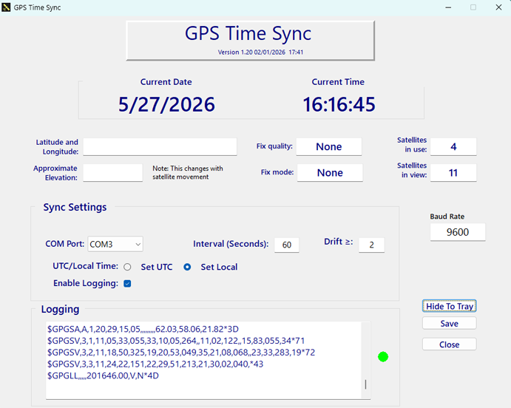
GPS Time Sync 1.20 main window
Area | What it means
Latitude and Longitude | Current GPS position when a valid fix is available.
Fix quality | GPS, DGPS, RTK, Float RTK, or None based on GGA fix quality.
Fix mode | GPS when RMC status is valid; None when it is not.
Satellites in use | Number of satellites used for the current fix.
Satellites in view | Visible satellites reported by GSV messages.
Approximate elevation | Altitude converted from meters to feet; normal GPS variation is expected.
Current Date / Current Time | GPS-derived time shown as local or UTC according to the selected mode.
Logging window | Incoming NMEA data when logging is enabled, plus diagnostic messages.

Synchronization Settings
Setting | Use
COM Port | The serial port assigned to the GPS receiver.
Interval (Seconds) | How often the program compares Windows time to GPS time.
Drift >= | The allowed difference, in seconds, before correction is attempted.
Set UTC | Sets Windows system UTC directly from GPS UTC.
Set Local | Converts GPS UTC through Windows time-zone rules and sets local time.
Enable Logging | Shows incoming NMEA sentences in the log window for troubleshooting.
Baud Rate | Displayed serial speed currently applied to the port.

Save behavior. In the current source, Save applies the interval, closes and reopens the serial port, and logs 'Settings saved'. It does not write persistent settings to an INI file.

Tray Operation
GPS Time Sync can run quietly from the system tray. Click Hide To Tray to hide the main window while keeping the program active. Click the tray icon to restore the main window.

Logging
Log | Purpose
Logging window | Shows live NMEA sentences when Enable Logging is checked.
GPSTimeChange.log | Records startup, shutdown, setting changes, time updates, and relevant errors beside the executable.
Maximum visible lines | The log window retains up to 500 lines while the application is running.

Troubleshooting
Problem | What to do
VK-172 not detected | Reconnect the receiver, open Device Manager, identify the COM port, select it manually, and click Save.
Cannot open COM port | Check that the selected COM port is correct and that no other program is using it.
Clock does not update | Run as administrator, confirm valid GPS time is being received, and check GPSTimeChange.log.
Elevation changes | This is normal. GPS altitude fluctuates with satellite geometry.
No NMEA lines shown | Confirm Enable Logging is checked and that the GPS receiver has a clear view of the sky.

Files Installed or Used
File or folder | Description
GPSTimeSync.exe | Main application executable.
Help\index.html | HTML help entry point opened by the Help button.
GPSTimeChange.log | Time-change and diagnostic log written beside the executable.
GPSTimeSync.lock | Single-instance lock file used while the application is running.
EULA.txt | End User License Agreement.

